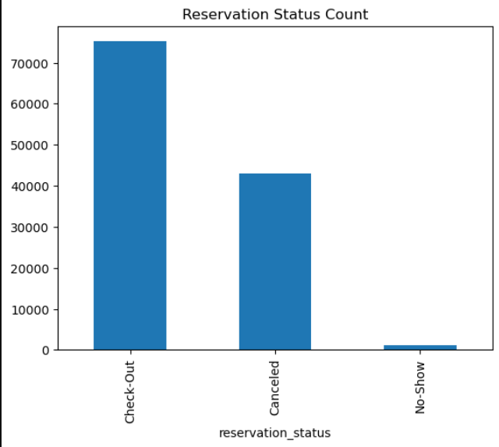

The chart shows that bookings have exceeded **70,000**, while cancellations have crossed over **40,000**.

This high cancellation rate is concerning for the business, as it indicates that many customers are making bookings but later cancelling them. This situation needs to be carefully analysed to identify the underlying causes and take corrective actions to reduce cancellations and improve booking reliability.

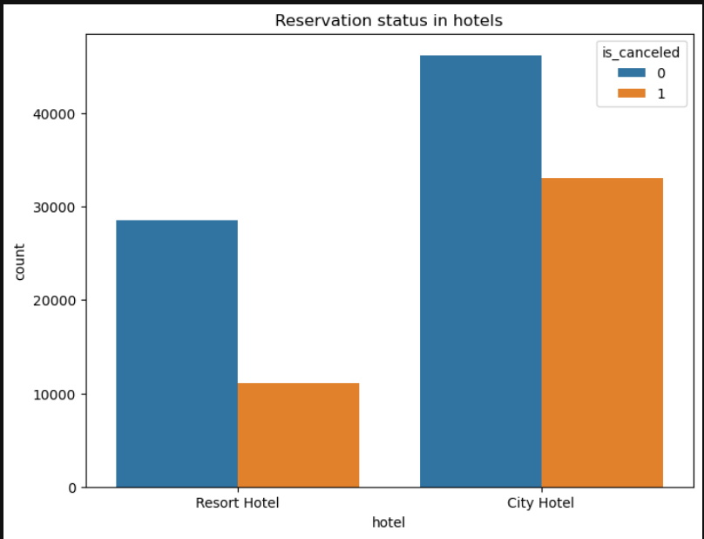

The City Hotel has a higher number of total bookings, but it also shows a significantly higher cancellation rate, indicating that more customers are facing issues leading to cancellations.

Although the Resort Hotel has fewer bookings overall, the proportion of cancellations compared to its total bookings is also relatively high.

This suggests that both hotels are experiencing cancellation challenges, but the City Hotel is more severely impacted.

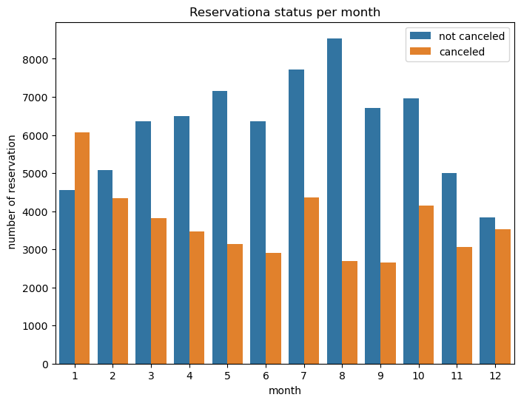

August shows the highest number of bookings with comparatively fewer cancellations, indicating strong business performance during this month.

In contrast, January has a higher cancellation rate compared to bookings, highlighting a potential issue that needs to be addressed during the early part of the year.

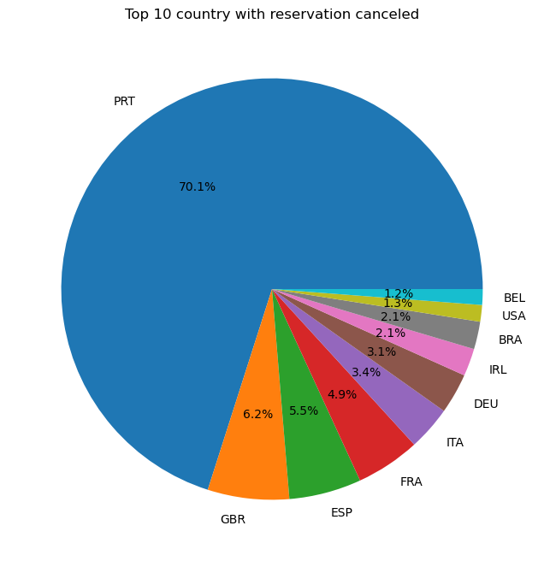

Portugal has the highest number of bookings, indicating a heavy reliance on one country. To reduce future cancellations and risks, it is important to diversify the customer base.

The least number of bookings are from the USA and Belgium.

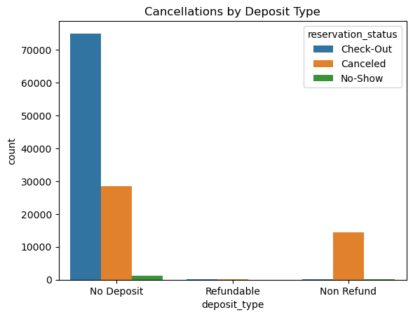

The chart shows that most customers with *No Deposit* successfully check out, but a significant number also cancel their bookings.

In contrast, customers with *Non-Refundable* deposits also show a high cancellation rate, suggesting the refund policy might not strongly prevent cancellations.

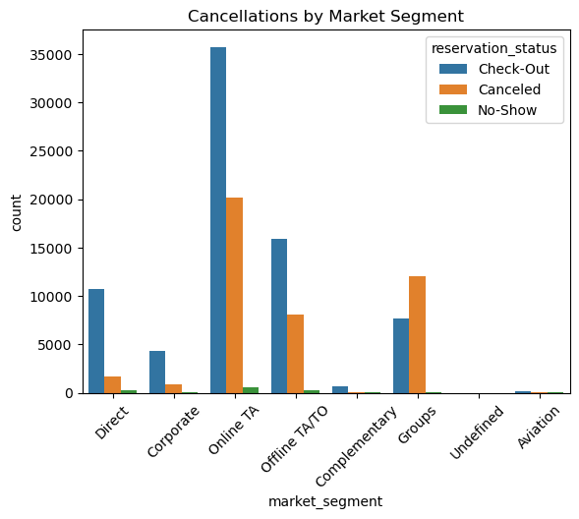

The chart shows that customers booking through *online travel agents* have a high number of both check-outs and cancellations.

In contrast, the *Aviation*, *Corporate*, *Complementary*, and *Undefined* sectors have much fewer cancellations.

Suggestions

**1)**  
Cancellation rates tend to increase as prices rise. To minimize cancellations, hotel management should work on controlling price fluctuations and maintaining stable pricing strategies.

**2)**  
According to the report, *Resort Hotels* should focus more on attracting *corporate* customers and clients from sectors with lower cancellation rates. This can also help boost positive customer experiences and lead to more promotions through word-of-mouth.

**3)**  
In addition to enhancing advertisements in other countries to diversify the customer base, the hotel should consider implementing a minimal advance registration fee. This small commitment can help secure bookings and provide some assurance in case of cancellations.

4)

More online method of advertisement should be use and promotion more though our existing channels (agents).